Name: Pranali Sonawane
Subject: CCNA
Date: 10-11-2025
Lab – Cisco Discovery Protocol(CDP):
First, we have taken five multilayer switches. The switches are connected using crossover cables. The first multilayer switch is connected to five PCs and configured with DHCP.
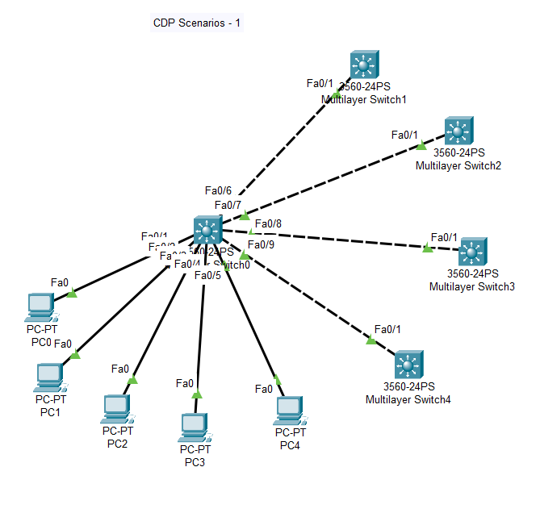
Open Switch 0 – CLI prompt then type following commands
Switch>enable
Switch#config terminal
Switch (config)#cdp run
Switch (config)#ip routing
Switch (config)#vlan 10
Switch (config-vlan)# name CCNA
Switch (config-vlan)#exit
Switch (config)#interface fastEthernet 0/1

Switch (config-if)#switchport mode access
Switch (config-if)#switchport access vlan 10
Switch (config-if)#no cdp enable
Switch (config-if)#no shutdown
Switch (config-if)#exit

Switch (config)#interface fastEthernet 0/2
Switch (config-if)#switchport mode access
Switch (config-if)#switchport access vlan 10
Switch (config-if)#no cdp enable
Switch (config-if)#no shutdown
Switch (config-if)#exit

Switch (config)#interface fastEthernet 0/3
Switch (config-if)#switchport mode access
Switch (config-if)#switchport access vlan 10
Switch (config-if)#no cdp enable
Switch (config-if)#no shutdown
Switch (config-if)#exit

Switch (config)#interface fastEthernet 0/4
Switch (config-if)#switchport mode access
Switch (config-if)#switchport access vlan 10
Switch (config-if)#no cdp enable
Switch (config-if)#no shutdown
Switch (config-if)#exit

Switch (config)#interface fastEthernet 0/5
Switch (config-if)#switchport mode access
Switch (config-if)#switchport access vlan 10
Switch (config-if)#no cdp enable
Switch (config-if)#no shutdown
Switch (config-if)#exit

Switch (config)#interface vlan 10
Switch (config-if)# ip address 10.0.0.1 255.255.255.0
Switch (config-if)#no shutdown
Switch (config-if)#exit

Switch (config)#interface fa0/6
Switch (config-if)# switchport trunk encapsulation dot1q
Switch (config-if)#switchport mode trunk
Switch (config-if)#switchport trunk allowed vlan 10
Switch (config-if)#no shutdown
Switch (config-if)#exit

Switch (config)#interface fa0/7
Switch (config-if)# switchport trunk encapsulation dot1q
Switch (config-if)#switchport mode trunk
Switch (config-if)#switchport trunk allowed vlan 10
Switch (config-if)#no shutdown
Switch (config-if)#exit

Switch (config)#interface fa0/8
Switch (config-if)# switchport trunk encapsulation dot1q
Switch (config-if)#switchport mode trunk
Switch (config-if)#switchport trunk allowed vlan 10
Switch (config-if)#no shutdown
Switch (config-if)#exit

Switch (config)#interface fa0/9
Switch (config-if)# switchport trunk encapsulation dot1q
Switch (config-if)#switchport mode trunk
Switch (config-if)#switchport trunk allowed vlan 10
Switch (config-if)#no shutdown
Switch (config-if)#exit

switch(config-if)#ip dhcp excluded-address 10.0.0.1 10.0.0.10
switch(dhcp-config)#ip dhcp pool VLAN10_POOL
switch(dhcp-config)#network 10.0.0.0 255.255.255.0
switch(dhcp-config)# default-router 10.0.0.1
switch(dhcp-config)#exit
switch(config)#show cdp neighbors

Open Switch 1- CLI prompt then type following commands
Switch>enable
Switch#config terminal
Switch (config)#cdp run
Switch (config)#interface fa0/1
Switch (config-if)# switchport trunk encapsulation dot1q
Switch (config-if)#switchport mode trunk
Switch (config-if)#switchport trunk allowed vlan 10
Switch (config-if)#no shutdown
Switch (config-if)#exit
Switch (config)#hostname switch1
switch1(config)#

Open Switch 2- CLI prompt then type following commands
Switch>enable
Switch#config terminal
Switch (config)#cdp run
Switch (config)#interface fa0/1
Switch (config-if)# switchport trunk encapsulation dot1q
Switch (config-if)#switchport mode trunk
Switch (config-if)#switchport trunk allowed vlan 10
Switch (config-if)#no shutdown
Switch (config-if)#exit
Switch (config)#hostname switch2
Switch2(config)#
Open Switch 3- CLI prompt then type following commands
Switch>enable
Switch#config terminal
Switch (config)#cdp run
Switch (config)#interface fa0/1
Switch (config-if)# switchport trunk encapsulation dot1q
Switch (config-if)#switchport mode trunk
Switch (config-if)#switchport trunk allowed vlan 10
Switch (config-if)#no shutdown
Switch (config-if)#exit
Switch (config)#hostname switch3
Switch3(config)#

Open Switch 4 – CLI prompt then type following commands
Switch>enable
Switch#config terminal
Switch (config)#cdp run
Switch (config)#interface fa0/1
Switch (config-if)# switchport trunk encapsulation dot1q
Switch (config-if)#switchport mode trunk
Switch (config-if)#switchport trunk allowed vlan 10
Switch (config-if)#no shutdown
Switch (config-if)#exit
Switch (config)#hostname switch4
Switch4(config)#

